MINI-PROJECT-UNIT-3

NAME : SIDDHESH ASHOK SONAWANE
PRN:2125UDSM1083
CLASS: AI & DS
YEAR : 2ND
DIVISION : A
Subject : DEV & OPS

PROJECT INFORMATION :

The mini project, Smart Library Management System, has been successfully developed and implemented as part of the DevOps assignment. The project source code, configuration files, Dockerfile, Jenkinsfile, test cases, and Kubernetes manifests have been maintained in the GitHub repository for version control and easy access. The application was tested using Pytest, containerized using Docker, automated through Jenkins CI/CD, deployed on AWS EC2, and orchestrated using Kubernetes with Minikube. Screenshots of the project execution and GitHub repository are provided below for reference and verification.

Git Hub Repository :
https://github.com/SiddheshSU/smart-library-management/tree/main

Step 1.Git Repository
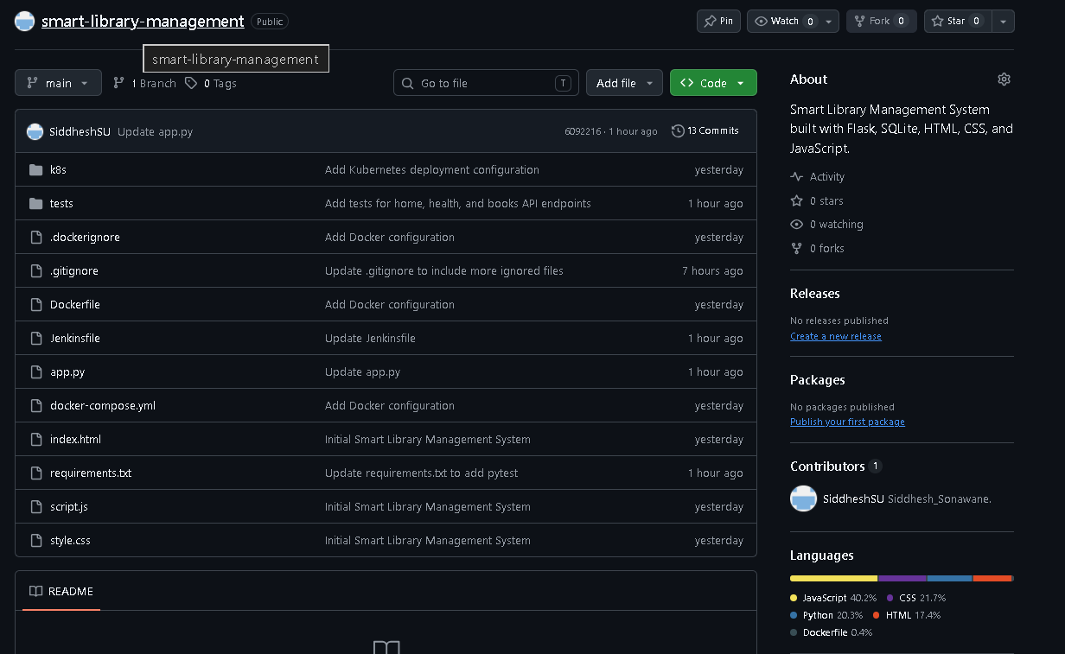
Step 2. AWS EC2 Instance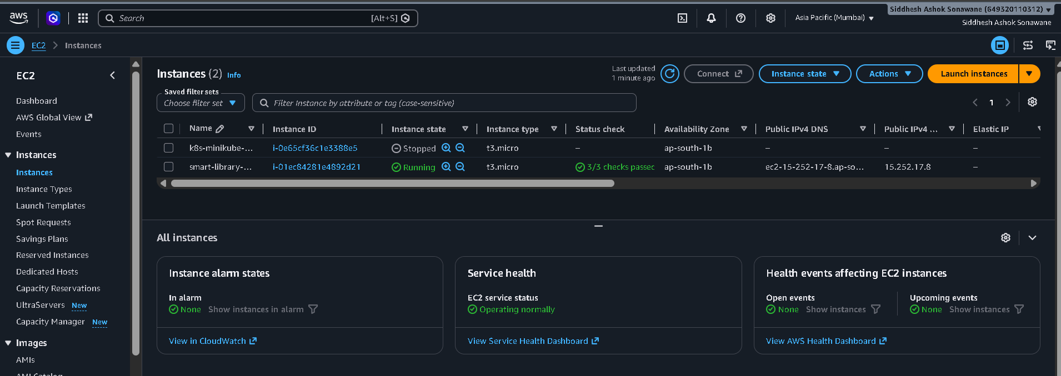
Step 3. MobaXtrem (SSH Connection)
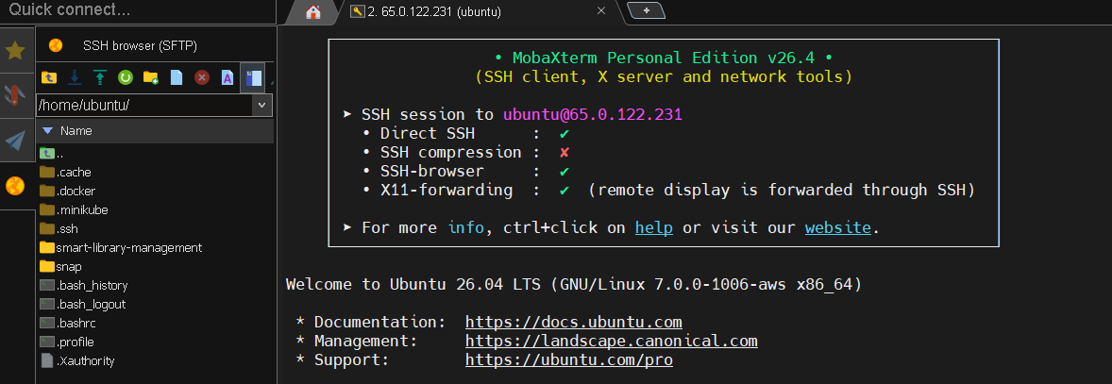

Step 4.Jenkins Pipeline (Successful)
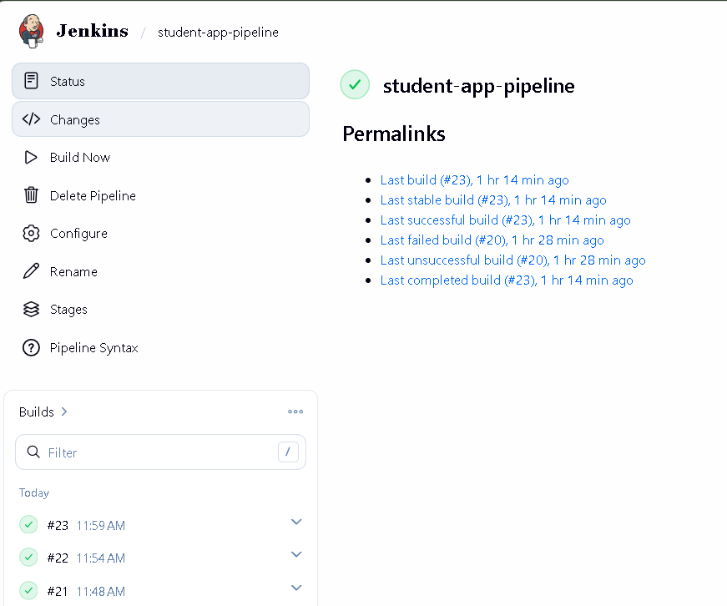
Step 4. Minikube
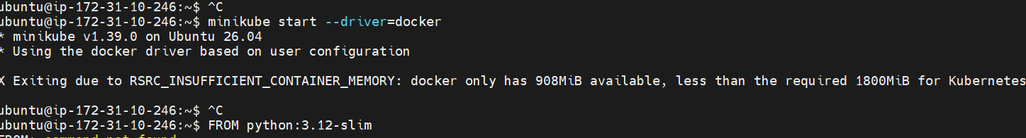
Step 5. Minikube & Kubernetes
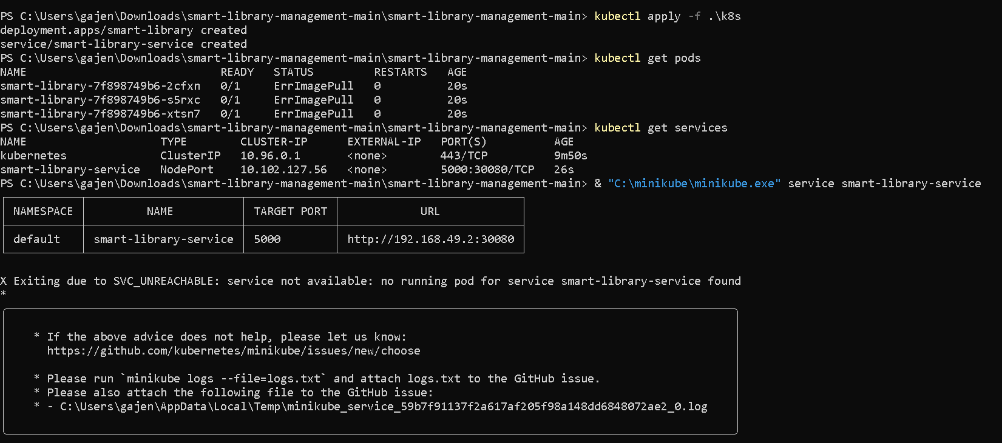
Step 6.Front Page (ENTERPRISE LIBRARY)
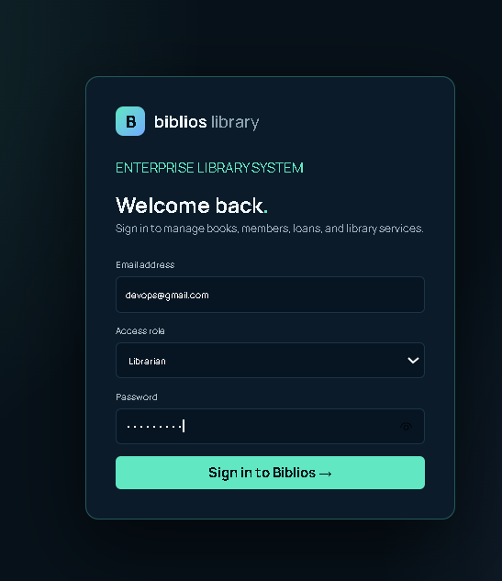

Main Page (ENTERPRISE LIBRARY)
